Blood on the Clocktower - Video Content Creation Guide and Acceptable Use Policy

Welcome to our video content creation guide. We think it’s awesome that you want to create awesome videos about our game. Consequently, we’d like to share with you what we’ve learned over the years about best practices when filming, editing, and presenting a game of Blood on the Clocktower in video form.

And whilst we love to see others playing and filming their Blood on the Clocktower experiences, in order for this to happen we also need to make sure that we're protected in various ways. Please see the 'Acceptable Use Policy' near the end of this document for more information.

Choosing a Script and Game Size
Blood on the Clocktower is a game that can take on a fairly diverse array of forms. Ultimately, when deciding to create filmed games of Blood on the Clocktower, the first questions you need to ask are ‘How long do I want the game to take?’ and ‘How complex do I want the game to be?’

Game Length
There is naturally some variance in this, but generally speaking, an in-person game of Blood on the Clocktower will take the following lengths of time to play.

Number of Players | Length of Game
7 - 9 | 1 hour
10 - 12 | 1.5 hours
13+ | 2 hours

If you’re running the game online or using the app, then things usually take a little longer than this, owing to the extra steps required to organise and referee player discussions.

Game Complexity
Blood on the Clocktower comes with three base scripts - Trouble Brewing, Bad Moon Rising, and Sects & Violets. It is very strongly recommended that for your first games as both player and/or Storyteller, you run Trouble Brewing.

Regardless of which script you choose to run, we’ve found that regularly explaining the mechanics to your audience makes for a much better viewing experience. There are a lot of mechanics at play in Blood on the Clocktower and more often than not, the compelling nature of the game as a spectator sport comes from understanding not just what is happening, but what could happen.

Finally, if you intend to run a game that contains characters, rules or elements that aren’t a part of the official Blood on the Clocktower script (i.e. ‘homebrew’), we request that you clearly explain to your audience that this is a modified version of the rules and isn’t representative of the game itself. Examples of this could be creating your own characters, running a game in which every good player is the same character, or running a game for more than 20 players.

Filming a Game of Blood on the Clocktower
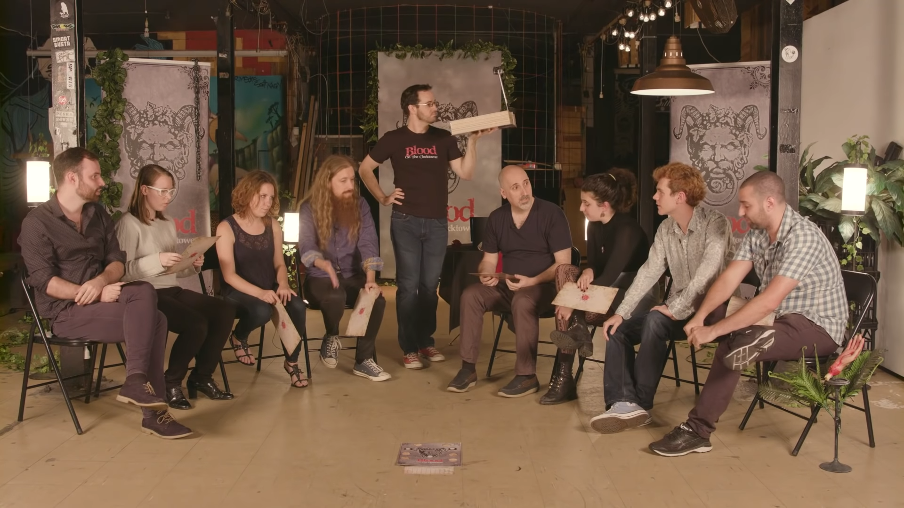
When filming an in-person game of Blood on the Clocktower, we’ve found that using a semi-circle (rather than the normal circle of players) ensures clarity for the viewer. It also enables the viewer to see who is whispering with who, and who is being woken in the night. A perfect example of this is our own playthrough video of Trouble Brewing.
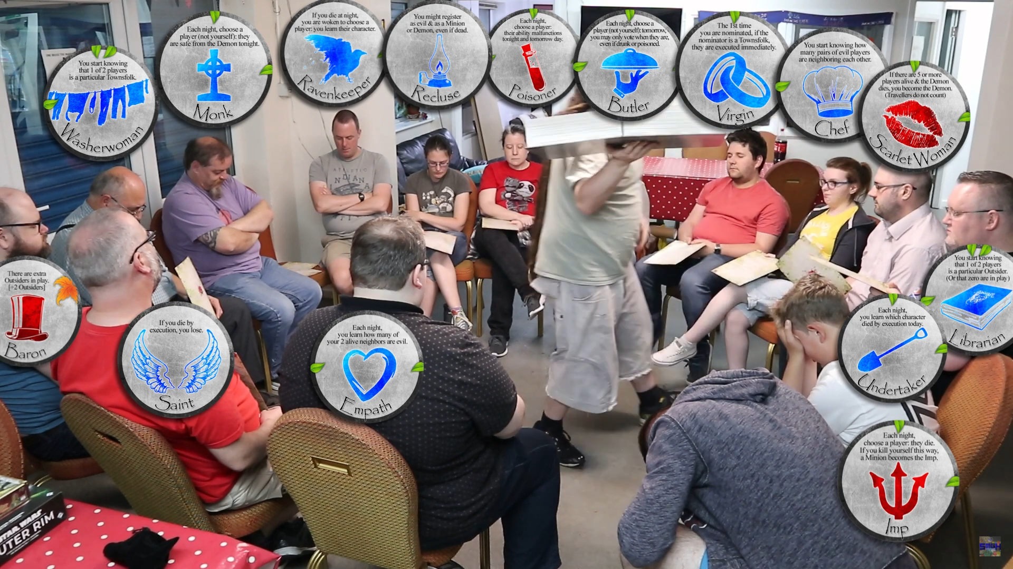
For larger games of Blood on the Clocktower, things are liable to get a little complex/messy. In situations such as these, you may want to consider regularly or constantly having some kind of visual reminder on screen so that the viewer knows who is who. A great example of this can be seen in Salford and Manchester Gaming Haven’s playthrough of Trouble Brewing.

Using the App
Currently, there is no official app for Blood on the Clocktower, but a very handy fan-made one exists at https://clocktower.online/. When using the app to create video content, there are a number of things you’ll want to keep in mind.

Voice and Audio
Unlike in real life, where physical and social cues make it easy for a large group of people to converse without interrupting one another, online it’s quite common for public discussions to get very messy, very quickly. Furthermore, it can be difficult for the viewer to understand who is talking, who’s being referred to, and which voice belongs to which player. There are a number of ways you can overcome this.
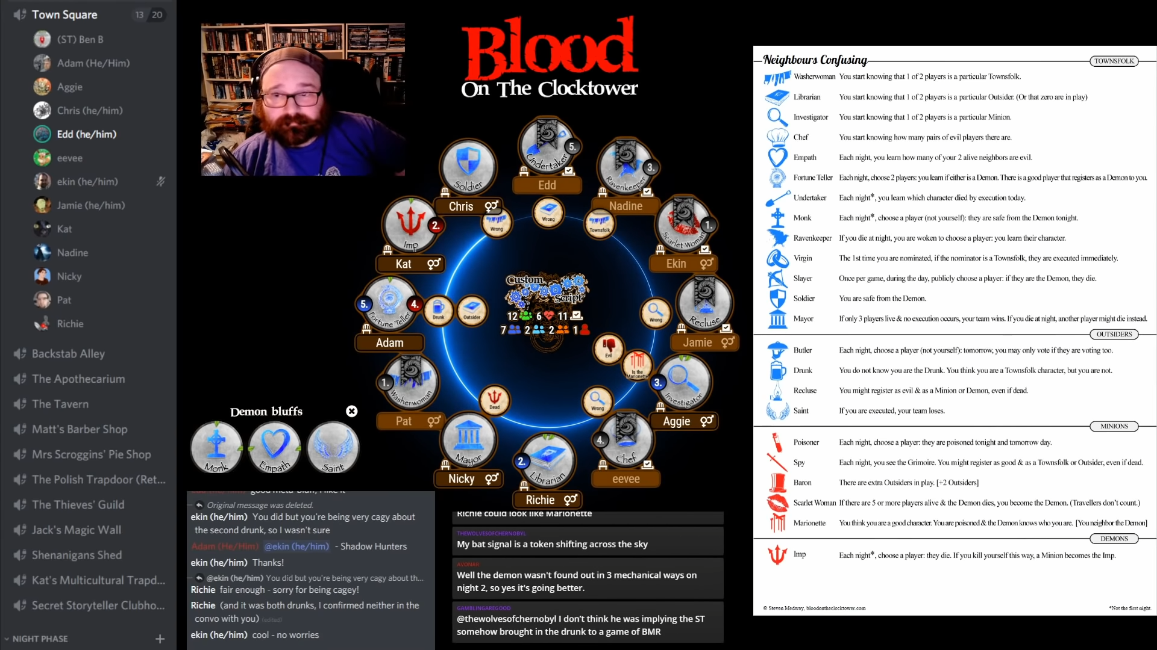
In the above example, you can see that we’re using the app to run the game, and Discord to host the voice chat. By ensuring that the discord app is visible, and insisting that each player use the same unique name in both Discord and on the app, we’ve achieved a degree of visual clarity. A player’s name lights up when they speak and our audience can easily correlate that with a particular token on the board.

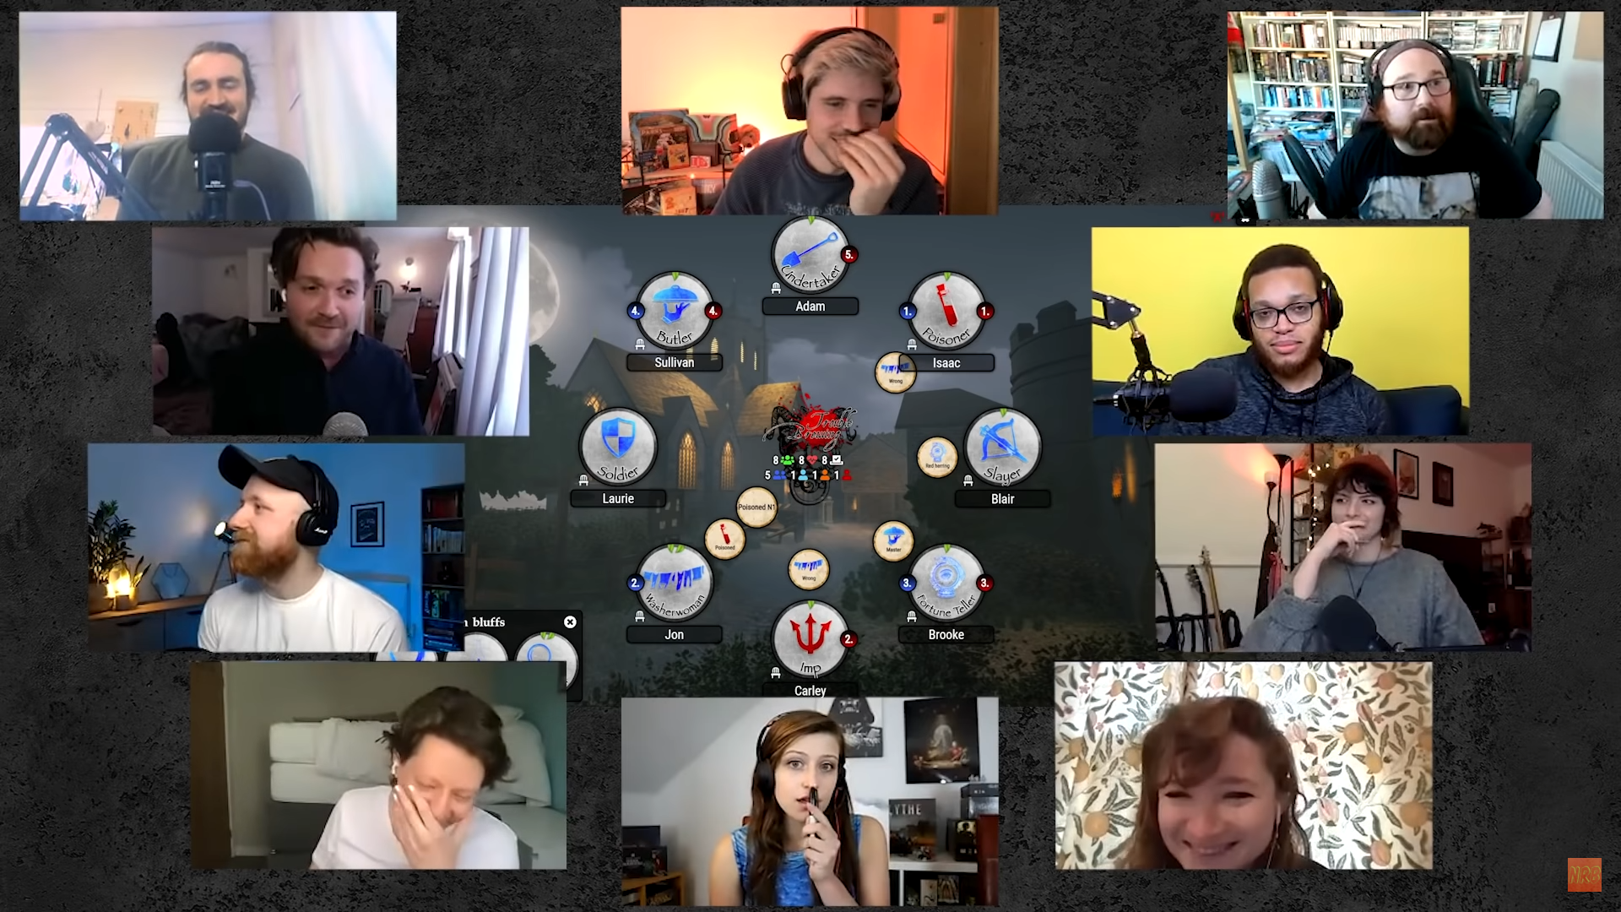
In this example from No Rolls Barred’s playthrough, the editor has placed webcam footage of each player next to their token on the board. This was achieved by using Zoom to capture and record the individual webcam of each player, then having each player individually record their microphone audio using Audacity. This method requires a lot of editing, but the results are of an extremely high quality.

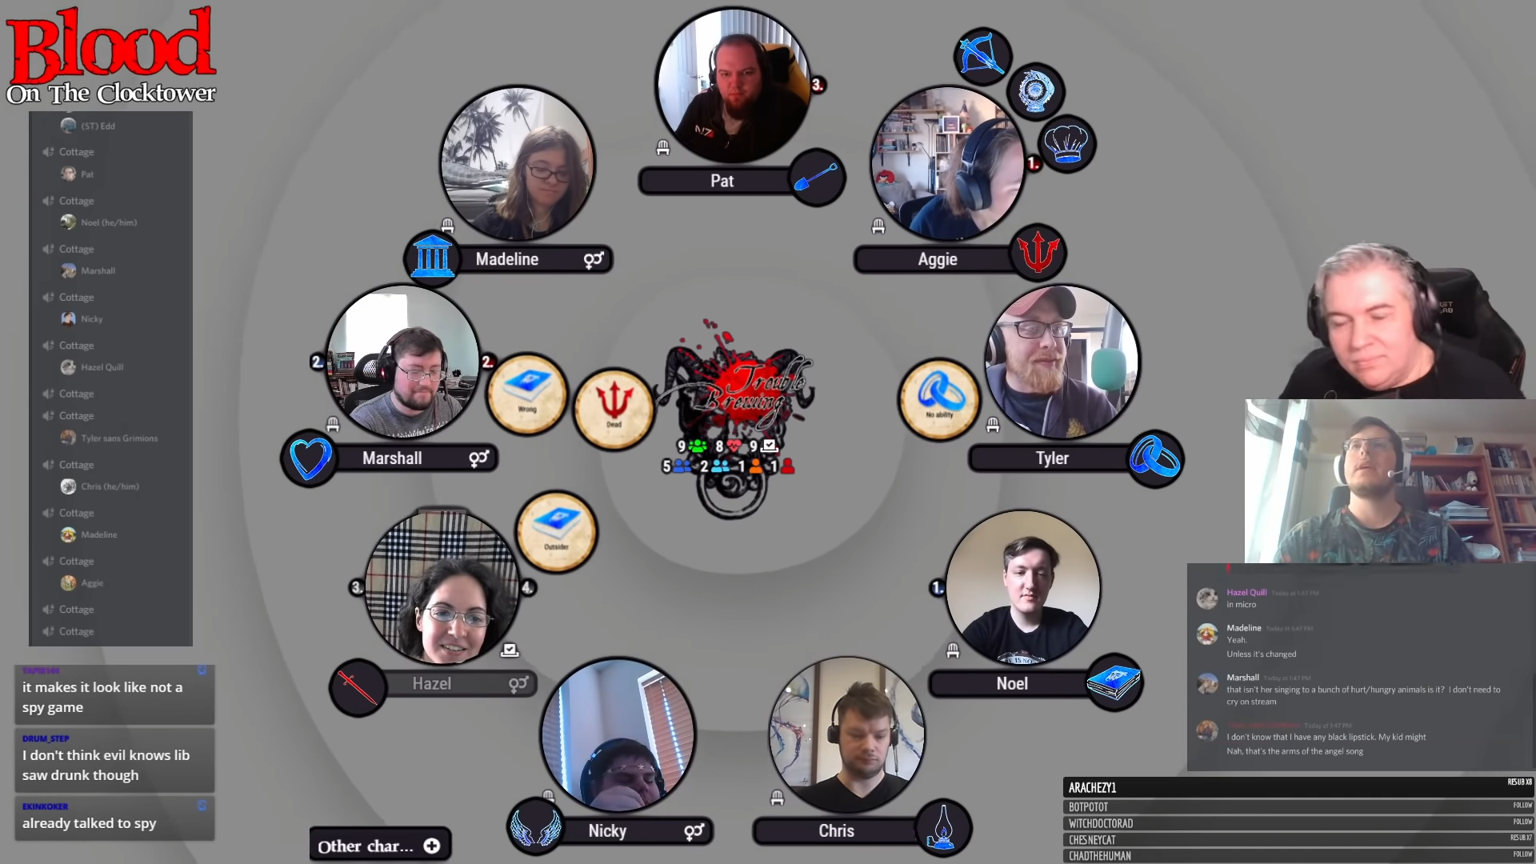
When live-streaming, a similar effect can be achieved by using OBS Ninja to capture each player’s individual camera and then setting them as a source using either OBS or Streamlabs OBS to stream/record your game. A perfect example of this can be found during one of our megastream games in which Adam used a combination of these pieces of software, as well as the layering system on OBS, to create the above effect.

Setting up a Discord Server for Online Games
If you’re interested in replicating the Discord setup from our own online games, here’s our guide on how to set your server up with cottages and the Moveer bot.

Additional Information & Acceptable Use
While we encourage you to create video content related to Blood on the Clocktower, and have created this guide to help you in those efforts, we currently do not officially endorse, sponsor, or approve of any such video content or any of the third party software applications listed in this guide. Further, while you own the rights to your own video content, that content is always subject to the limitations we set forth below and our ownership over the game content itself.

Accordingly, by playing and filming your Blood on the Clocktower games, you acknowledge and agree to the following:

Ownership of the Game
We are the owner of all rights in the Blood on the Clocktower game, including all intellectual property rights and moral rights. You agree that you will not take any action inconsistent with this ownership (like claiming that the game is your own, using the game’s name as a trademark or brand name for yourself, or registering a domain name with the game’s name in it). We reserve the right to enforce any of our rights in the game and revoke our limited license for you to use the game in connection with your videos.

With respect to any derivative works of our game, you further agree that you may not create, publish, or distribute such works except as authorized by us in writing.

Limitations on Your Use
Given that we have an interest in how Blood on the Clocktower is used, we may limit the ways in which you use our game. Any use of Blood on the Clocktower that we consider unacceptable, will be treated as an infringement of our copyright and trademark rights in the game.

In particular, while filming, streaming, or otherwise making your video of playing Blood on the Clocktower publicly available, you agree that you will not and will not assist any other person under any circumstance to:

- Take any action or upload, post, transmit, promote, or distribute any illegal content or content that violates any third-party rights.
- Engage in, take any action associated with, or participate in any offensive, immoral, or illegal behavior.
- Harass, stalk, threaten, embarrass, spam, or do anything else to another user of the game or viewer that is unwanted. This includes repeatedly sending unwanted messages or making personal attacks or statements about race, sexual orientation, religion, heritage, or any other personal characteristic.
- Take any action or make any statement that gives the impression that your content is officially sponsored by or associated with us, including the use of the Blood on the Clocktower or The Pandemonium Institute trademarks.
- Take any action or upload, post, transmit, distribute, or communicate anyone’s personal information without their express consent.

Again, we will treat any attempt to do any of the foregoing as a violation of our intellectual property rights in and to the game, and at all times, we reserve the right to enforce our rights as necessary.

Extra Help
We hope you’ve found this guide helpful. If there is anything else we can do to help, please do not hesitate to contact our community manager, ben, via ben@thepandemoniuminstitute.com.

